Loan Origination Copilot Architecture Diagram
  - Standalone architecture reference with labelled layers, responsibilities, and data boundaries
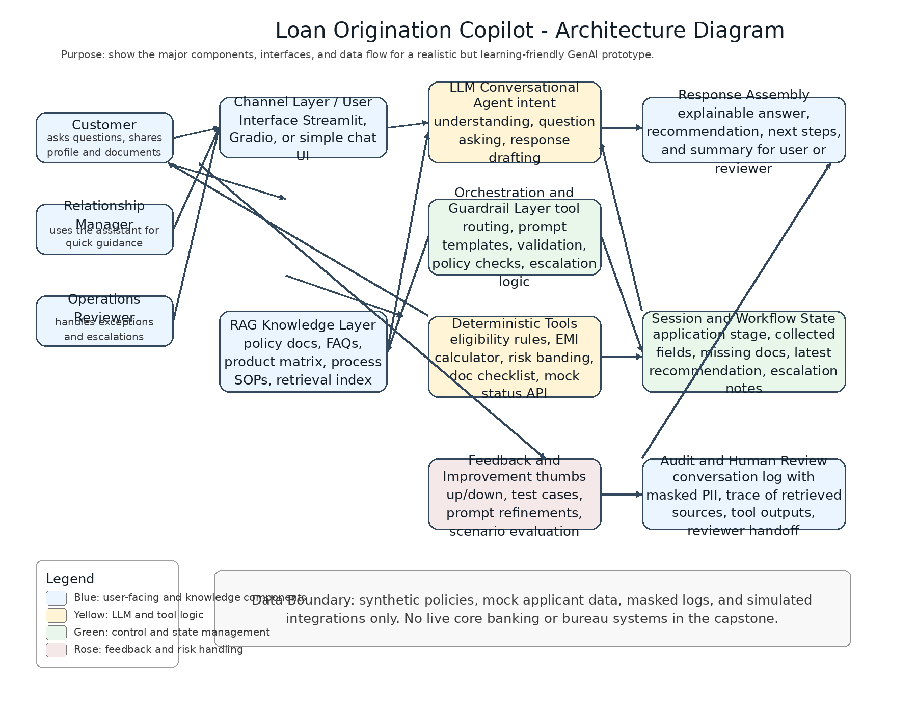

1. Architectural intent
The architecture is designed to resemble a real GenAI application stack without introducing enterprise infrastructure overhead. Each layer has a clear responsibility so the prototype remains explainable, modular, and testable.

2. Component explanation
Component | Responsibility
Channel Layer / User Interface | Collects user messages, displays responses, and presents outputs in a simple chat-oriented experience.
LLM Conversational Agent | Understands intent, asks follow-up questions, drafts responses, and manages natural-language interaction.
Orchestration and Guardrail Layer | Decides when to retrieve knowledge, when to call tools, what validations to run, and when to escalate.
RAG Knowledge Layer | Supplies policy-grounded content such as product rules, FAQs, and document guidance.
Deterministic Tools | Handles calculations and rules that must remain stable and auditable, such as EMI and eligibility estimates.
Session and Workflow State | Maintains the current stage, collected fields, and pending actions within the user journey.
Feedback and Improvement | Captures evaluation signals and supports iterative refinement of prompts, rules, and scenarios.
Audit and Human Review | Stores masked logs and reviewer summaries for transparency and exception handling.

3. Implementation note
A practical student implementation can use Streamlit for the interface, a hosted LLM API for conversational intelligence, a vector store for retrieval, and simple Python modules for tools and orchestration. This is enough to demonstrate a professional design without taking on bank-scale deployment complexity.

